

|  |  |
| --- | --- |
| Version | V2 |
| Name of responsible  (ratifying)  committee | Thames Valley & Wessex ODN Oversight Committee |
| Date Ratified |  |
| Document  Manager(s) (job  title) | Gill Leaver, Network Lead Nurse  Carolyn Barrett, TV&WODN Transfer Group Chair  Nikolaos Makris, TV&WODN Transfer Medical Lead |
| Date Issued | Oct 2020 |
| Review date | Oct 2022 |
| Electronic  Location |  |

Contents

1.0 Introduction 4

2.0 Background 4

3.0 ACCEPT – StaR (2006) 5

4.0 Decision to transfer 6

5.0 Communication in relation to transfer 7

6.0 Assessment and stabilisation prior to transfer 8

7.0 Preparation for transfer 11

8.0 Carrying out safe transfer 15

9.0 Handover following transfer 20

10.0 Competencies 21

11.0 Reference List 22

Appendix A Thames Valley and Wessex Adult Critical Care Operational Delivery Network 23

Appendix B Thames Valley & Wessex ACC ODN Transfer Form (v1.2 updated August 2019) 24

Appendix C Transferring the patient with an intra-aortic balloon pump in situ 26

Appendix D Transferring the Neuro Patient 28

Appendix E Transferring the Spinal Patient 30

Appendix F Transferring the patient for an MRI scan 31

Appendix G Aero medical considerations 32

Appendix H Ambulance Escalation 33

Appendix I Hyperlinks 35

Appendix J Logbook 36

Version Control: 37

# 1.0 Introduction

The aim of this Critical Care Transfer Awareness Package is to ensure that all staff involved in the transfer of critically ill patients receive training in transfer medicine as per the ICS guidelines (2019).

This package comprises of the handbook, a study day and completion of competencies, which is aimed to provide all clinical staff involved in the transfer of level 2 and level 3 patients with the fundamental concepts that promote safe inter and intra hospital transfer. This training is in conjunction with the Thames Valley and Wessex Adult Critical Care Operational Delivery Network Transfer Policy and your local unit and Trust Transfer Policies.

The handbook will highlight the physiological, logistical, legal, and ethical issues that may arise in transfer.

Following initial resuscitation and stabilisation, critically ill patients may require secondary transfer. Furthermore, as services once again become more centralised and specialised (such as major trauma, stroke, and other direct specialised pathways) the numbers of critically unwell patients requiring clinical transfer will increase. Indications for such transfers include:

* Specialist intervention not available in referring hospital
* On‐going support not available in referring hospital
* Specialist investigation not available in referring hospital
* Lack of staffed intensive care bed in referring hospital
* Repatriation back to referring hospital

# 2.0 Background

Compressive critical care made planning for inter hospital transfers of critically ill patients mandatory. As a result, networks were established to co-ordinate and develop transfer services within defined geographical areas. Members of our network are detailed in **Appendix A.**

For transfers, the network is organised into transfer groups with the intent of pooling the limited critical care resources available on each site. This is intended to limit the distance of transfers by defining routes of referral enabling the process to run more smoothly.

Each trust should have a nominated consultant and senior nurse responsible for intra and inter-hospital transfer of critically ill patients. They are responsible for ensuring that a process is developed within their trust to facilitate safe transfers including:

* Establishment and training of transfer personnel.
* Availability of equipment compatible with transport modes utilised.
* Development of a trust transfer policy in line with the rest of the network.

# 3.0 ACCEPT – StaR (2006)

Transferring critically ill patients inter (between) and intra (within) hospitals presents an increase in clinical risk. The potential benefits of the transfer must be weighed against the risk; it must be established that this transfer is in the best interests of the patient and that an additional level of care (treatment or investigation) is actually required which is not available in the current location.

To ensure the right PATIENT, is taken at the right TIME, by the right PEOPLE, to the right PLACE, by the right form of TRANSPORT a systematic approach is required. This must incorporate a high level of planning and preparation. The STaR manual (2006) recommends A.C.C.E.P.T acronym as a helpful reminder which can be applied at various aspects of the process.

**A** Assess the situation

- What are the reasons for the transfer?

- Use a systematic approach to assess the patient and situation (ABCDE)

**C** Control the situation

- Organise people and events

- Allocate appropriate tasks and personnel

**C** Communication

- Understand what needs to be communicated during the transfer process

- Understand who should be communicating with each other

- Understand the need for concise, relevant communication of information

**E** Evaluate the need for transfer

- assess whether transfer is necessary

- Quantify clinical urgency for transfer

**P** Package and Prepare

- Understand the preparation of the patient, equipment and personnel

- Understand the packaging of the patient

**T** Transportation

- Understand the key factors that determine which mode of transport is the most  
 appropriate and differences between them

- Understand the booking process

# 4.0 Decision to transfer

The decision to transfer a patient is always the joint responsibility of the referring and receiving clinicians. The medical staff at the receiving unit may offer specialist advice on patient management however, responsibility for the patient always lies with the clinician in attendance who may, if circumstances change, decide not to transfer, (ICS 2019) or decide how the transfer is undertaken (such as deciding to intubate and ventilate the patient).

4.1 Indications for transfer

Decisions to transfer a patient may be made for the following reasons:

* Escalation of level of care
* Specialist surgical procedure/intervention or investigation
* De-escalation of critical care
* Repatriation

These decisions are usually straight forward, and the main consideration is likely to be the optimal timing of the transfer. Another possible reason for transfer is a lack of critical care capacity, this presents more ethical considerations when making the decision to transfer (see below).

4.2 Risk benefit

The risks associated with transferring a patient must be balanced against the benefits of the transfer. If the patient is unstable and transfer is likely to cause further deterioration, consideration should be given to alternative courses of action available. It may be necessary to delay the transfer until the patient becomes more stable, consultation with the receiving unit may aid this assessment if transfer is for specialist treatment. Consideration should also be given to the advantages and disadvantages of different modes of transport available from physiological and time perspectives. An assessment of the risk benefit of time over possible physiological compromise may be necessary. The ICS (2019) give an example of a risk assessment you could use.

4.3 Ethical issues of transfer

The main ethical consideration in relation to transfer is when transferring due to a lack of critical care beds. The contentious issue here is whether to transfer a new potentially unstable patient or an existing patient who is more stable and less likely to deteriorate during transfer. The ICS (2019) state in general no patient should be subjected to an intervention that is not in their best interests and that it could therefore be considered unethical to transfer one patient out of a critical care unit for the sole purpose of making room for another.

Other ethical considerations are the patient's ability to consent and the requirement of the Mental Capacity Act (2005). Where the patient is unable to consent to the transfer, it may be necessary to consult the patient’s relatives. **In all cases, the decision to transfer and the reasons for the transfer must be clearly documented in the patient’s notes.** Discussions with patients’ relatives must also be documented in the medical notes.

4.4 Policies on transfer

There are several policies and guidelines relating to the transfer of critically ill patients. Those involved in the transfer of these patients should be familiar with these policies and guidelines and how to access them. They include:

National - ICS 2019

Regional – SCAS, SWASFT, TVWACC ODN

Local – Trust, Departmental

# 5.0 Communication in relation to transfer

Clear effective communication and record keeping are an essential part of the transfer process. Communication begins at the point of referral and needs to be continued throughout all stages of the transfer process. To ensure that communication is effective information needs to be concise and relevant and needs to be interpreted correctly.

5.1 Telephone communication

Many different methods of communication may be used throughout the transfer process but most communication that takes place will be via the telephone and so it is useful to use a systematic approach such as:

S - Situation

B - Background

A - Assessment

R – Recommendations

**S – Situation**

Introduce yourself to the patient and check that you are speaking with the correct person.

Identify the patient you are calling about (who and where)

Discuss anything you need advice on

**B – Background**

Background information about the patient

Reason for admission

Relevant past medical history

**A - Assessment**

Specific observations and vital sign values based on an ABCDE approach

Any specifics that are required to resolve any problems

Therapies that have already been instituted and the response made to such therapies

Any infection control issues that may need to be considered.

**R – Recommendations**

State explicitly any actions that need to be carried out by the person you are calling/talking too

This is of relevance when transferring a patient to a specialist centre.

One of the most important telephone calls during the transfer process is the one to the receiving unit prior to departure; however, this is often forgotten in the pressure to get going. It is also wise to take a mobile phone and telephone numbers of both the referring and receiving units as these may prove extremely valuable during any unexpected events. Check the numbers on the transfer form to ensure they are up to date; you may also be transferring to Theatre/Cath Lab so you may need to obtain these numbers.

5.2 Written communication

Aside from communication on the telephone, the next important method of communication is written records. These are important from both a clinical and legal perspective, once a transfer has been completed; written notes are often the only record that will remain. It is usually necessary to reproduce written notes for the receiving unit for inter hospital transfers as original copies are usually retained by the referring hospital.

Documentation of the transfer itself is something that is often neglected but is as important as all other documentation. Forms for both inter and intra hospital transfers are available the current version of which is at **Appendix B.** Ensure that the patient (if able), along with relatives and significant others, is informed of the transfer, the destination, time and reason for transfer and this conversation is documented in the patient’s notes. Patient confidentiality should be considered and maintained during all communication, be it verbal or written.

# **6.0 Assessment and stabilisation prior to transfer**

Key considerations should be:

* The condition of the patient – ABCDE approach
* The capabilities of the transfer team
* Who holds responsibility for the patient’s care – in some cases will be dual care i.e. involvement of an external specialised unit.

Key questions to assist with assessment:

* What would affect the decision to transfer the patient?
* What are the benefits of transferring the patient?
* Why is the transfer being considered?
* Who has made the decision transfer?
* Who has accepted the patient?
* Where is the patient going?
* Who else needs to know?
* What is the patient’s diagnosis?
* What treatment are they receiving?
* What effect is it having?
* What is needed now?

Transporting patients is potentially hazardous. By adopting a systematic approach and considering the physiological effects of the transfer on the patient and taking action to minimise these where possible, will reduced the chance of avoidable adverse incidents occurring.

6.1 Airway

* Assess the patient's ability to maintain their airway, including if their gag and cough reflexes are sufficient.
* Secure the airway with elective intubation if there is any doubt about its patency or the patient’s level of consciousness. Guidelines for elective intubation pre-transfer:

GCS <9 (or expected to fall to this level during transfer)

Respiratory rate >30

Patient tiring

PaCO2 rising

Control of ICP

FiO2 >60%

Risk of aspiration

Risk of airway swelling e.g. facial burns.

Unstable Patient or ‘just in doubt

* If intubated, oral/nasal/tracheostomy check the position of the ETT on a chest x-ray and by clinical examination

6.2 Breathing

* Assess the adequacy of the patients breathing, including respiratory rate, work of breathing, air entry breath sound, oxygen saturations and arterial blood gas
* Review the chest x ray
* Treat any reversible causes for inadequate breathing/ventilation such as bronchospasm, pneumothorax, pleural effusion, or pulmonary oedema.
* If breathing remains inadequate consider elective intubation (see above guidelines for elective intubation pre-transfer)
* If chest drains are in situ, check they are functioning correctly, do not clamp chest drains, and keep underwater seal drains below the level of the patient. If they are on suction, consider if they need to be and if so, how you will maintain this during transfer. Standard wall suction is not suitable for chest drains.

6.3 Circulation

* Assess the cardiovascular system including heart rate and rhythm, blood pressure and perfusion.
* If there is evidence of hypovolaemia, correct with fluids. (A full patient travels better, see physiological effects of transfer 9.1)
* Control blood loss where possible; consider transfusion if Hb is less than 8g/dl.
* Commence inotropes or vasopressors if appropriate.
* Ensure you have adequate access. A minimum of 2 large bore cannulas should be in situ and easily accessible.
* At times it is necessary to transfer a patient with an inter aortic balloon pump (IABP) in place. This requires careful consideration and liaison with the ambulance service (**Appendix C** transferring the patient with an IABP).

6.4 Disability

* Assess GCS, pupil size and reaction, look for any abnormal movement and signs of seizure activity and evidence of pan or agitation.
* Consider the need for sedatives to control any agitation. Agitated patients pose an injury risk both to themselves and others during transfer.
* Control any seizures with anticonvulsants.
* Consider the need to electively intubate the patient if unable to control seizures or manage agitation or if there is evidence of brain injury, encephalopathy or coma (see above guidelines for elective intubation pre-transfer)
* Assess evidence of or potential for raised intercranial pressure. If present transfer the patient with 10-15 degree head up tilt and maintain MAP >80mmHg, PaO2 of 13KPa and PaCO2 of 4.5-5KPa. (**Appendix D** Transferring the Neuro Patient)
* The cervical spine should be immobilised in patients with a suspected or known neck injury. (**Appendix E** Transferring the Spinal Patient)

6.5 Environment

* **Biochemistry**

- Check blood glucose and treat if required (beware of administering treatment for hyperglycaemia if the patient will not be receiving any form of calories during transfer)

- Check U and E's, FBC and clotting

- Check ABG's

* **Gastrointestinal**

- Consider the need for anti-emetics in awake patients to prevent sickness induced by movement.

- Consider the need for a nasogastric tube in all patients. Intubated patients, unless contra indicated, should have a nasogastric/orogastric tube inserted pre-transfer.

* **Renal**

- Consider the need for a urinary catheter. Most critical care patients will require one for haemodynamic monitoring.

- Assess urine output and give fluid boluses or diuretics if required.

- More specific guidance can be found in the Wessex Kidney Centre Transfer Policy and Check List V2

* **Temperature**

- Check temperature and commence warming or cooling therapies if indicated.

- Keep patients warm and well covered.

- Attempt to complete all procedures prior to transfer to reduce risk of exposure.

* **Skin/Pressure Areas**

- Assess all pressure areas including potential equipment associated damage

- Assess any wounds and dress/redress if required.

# 7.0 Preparation for transfer

Preparation and packaging both have the aim of ensuring patient transportation proceeds with minimum change in the level of care and no deterioration occurs in the patient’s condition on route. Prior to packaging, four key areas must be considered.

* The Patient
* The Equipment
* The Personnel
* The Documentation

Adequate preparation of the patient, the equipment, and the transfer personnel, together with attention to the details of packaging will ensure that the transportation phase has the best chance of being adverse free. Some transfers require specific preparations; this includes MRI scans, according to your local Trust policies. (**Appendix F** Transferring the patient for an MRI scan).

7.1 The Patient

* Stabilisation of the patient must have occurred, and the patient's condition must be optimal. An inadequate resuscitation or missed injury will result in instability during the transfer and have adverse outcomes. Again, using the ABCDE approach is useful at this point.
* Find out which side of the ambulance you will load the patient as this will affect were you will attach equipment. Generally, patients are loaded onto the driver's side of the vehicle.
* Ensure the patient is adequately protected from the elements they may need to be insulated including the head. They may require protection for eyes and ears depending on the mode of transport.
* Ensure the patient has adequate analgesia and consider the need for an antiemetic in awake patients.
* Ensure the patient is stable on the transfer equipment. If possible, transfer the patient onto the transfer trolley and attach all the equipment before the ambulance crew arrives, this allows you to monitor them for a period, prior to departure, including doing an ABG. Equipment should be plugged into mains power and piped oxygen for as long as possible prior to departure.
* When transferring the patient onto the trolley, ensure the patient is packaged appropriately. This involved maintaining the safety and security of the patient, the staff, and the equipment
  + All lines and drains secured to the patient
  + The patient secured to the trolley
  + The trolley secured to the ambulance.
* Consider the potential for pressure damage to the patient and ensure all lines and equipment are secured in a way which will not cause pressure.

7.2 The Equipment

To transfer your Critical Care patient, you will require a range of equipment such as a transport ventilator, monitor, syringe pumps and a transfer bag. It is important to remain as self-sufficient as possible whilst on a transfer, so it is vital you are familiar with the kit, happy to troubleshoot and are fully aware of battery capacity. ICS guidelines (2019) highlight the importance of equipment and the following recommendations have been made.

Equipment used for transfers should be dedicated solely for this purpose and should be checked prior to use on patient.

All equipment should always be kept on charge. It is vital to be aware of battery life and carry spares in case of power failure. Battery management should also be carried out as per manufacturer’s guidance to ensure the length of the battery life.

The airway kit should always be kept at hand.

As much kit as possible should always be mounted at or below the level of the patient for safety. All equipment including transfer bags should be stowed securely, it may be necessary to use ambulance lockers to facilitate this. **Any piece of equipment that is not properly secured has the potential to become a missile in the presence of vehicle acceleration or deceleration forces and should therefore be stacked against the forward bulkhead to limit movement in event of sudden deceleration.**

* **Ventilator** Portable Mechanical Ventilators should have as a minimum: disconnection and high-pressure alarms, the ability to supply PEEP, variable Fi02, I:E ratio, respiratory rate, and tidal volume. In addition, the ability to provide pressure-controlled ventilation, pressure support and CPAP is desirable (ICS 2019). Non invasive ventilation machines, unless specifically designed for interhospital transfers should **not** be used.
* **Monitoring** Portable monitors should have a clear illuminated display and be capable of monitoring ECG, oxygen saturations, non-invasive blood pressure, two invasive pressures, capnography, and temperature. Alarms should be visible as well as audible (ICS 2019).

The minimum standard for monitoring laid out in the ICS 2019 guidelines is

* + Continuous cardiac rhythm (ECG) monitoring
  + Non-invasive blood pressure (NIBP is sensitive to motion artefact and unreliable in moving vehicles. It also places a significant drain on the monitor battery therefore invasive monitoring should normally be used.)
  + Oxygen saturation
  + End tidal carbon dioxide (in ventilated patients)
  + Temperature
* **Suction** Although suction is available in most ambulances and CT / MRI areas portable suction may prove vital along corridors and in lifts. It is therefore important to check it is working prior to departure and that all consumables are present.
* **Transfer bag** It is important to be familiar with the contents of the transfer bag. Transfer bags are often kept sealed to reduce the need for checking the contents. You should ensure all the seals are intact prior to transfer and that you are able to break the seals if you require access to the contents (you may need to carry a pair of scissors).
* **Drugs** Infusions should be rationalised, and only essential infusions and fluids continued. The amount of drug required for the duration of the transfer should be calculated and appropriate amounts drawn up and taken. A plan should be made for failure of pumps during transfer. For example, if the inotrope pump fails, we will bolus sedation to free up another pump for the inotrope. Ensure you calculate for any delays in transfer such as traffic or patient deterioration. Better to take more than not have enough to maintain patient stability and comfort.

**Oxygen calculation**

One of the most important considerations for the transfer team is the accurate calculation of oxygen supply required for the transfer. If going on a ‘inter’ hospital transfer then ambulances have an oxygen supply which should always be utilised, ensure you check with the crew what oxygen they carry and ask them to bring a portable cylinder up to the unit for the transfer to the vehicle. Taking an oxygen cylinder from the unit may cause problems should the ambulance be unable to return you to your unit after the transfer. On Intra hospital transfers, wherever possible you should utilise wall oxygen especially if the procedure or scan is going to take a prolonged time.

* + Patient’s current minute volume(MV). MV= tidal volume x respiratory rate
  + Transfer time = Journey time + 15 minutes loading + 20 Minutes unloading
  + Assume the patient will require 100% oxygen for the duration of the transfer
  + **(MV + driving gas) x transfer time in minutes = Oxygen required**
  + **Double if you want to be very safe**

*Cylinder Capacity*

* + D = 340L
  + C/D = 460L
  + E = 680L
  + F = 1360L
  + G = 3400L
  + ZX= 3040

**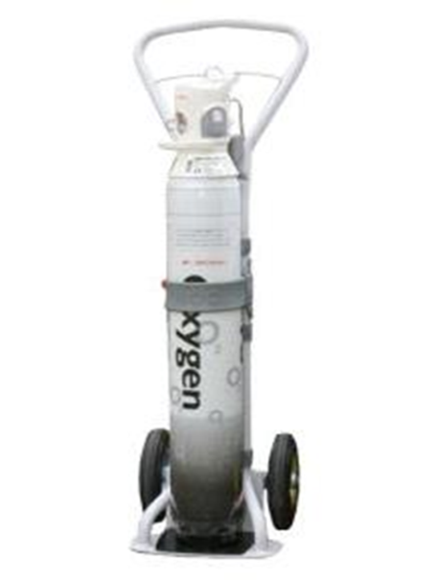

7.3 The Personnel

Level 3 Critical Care transfers always require a minimum of 2 attending personnel.

ICS (2019) recommendations are one medic with appropriate training in intensive care medicine, anaesthesia or emergency medicine should be competent in resuscitation, airway management and ventilation. The Second attendee is usually a nurse who should be appropriately qualified and experienced as well as having undertaken some form of formal transfer training. Thinking about human factors, the transferring team should discuss and make plans for possible scenarios that could take place during the transfer and ensure that roles are delegated, and plans are put in place for such events.

High visibility/warm clothing, a mobile telephone, contact numbers, money should always be carried in case of emergency.

Prior to departure, attendees who have not been involved in the initial care of the patient should take the time to familiarise themselves with the patient’s history and treatment (ICS 2019).

7.4 The Documentation

Documentation is a legal and permanent record of the transfer process. Clear records of all stages must be maintained. Standardised documentation in the way of transfer checklists have been created to ensure that core data is documented, and vital components are remembered prior, during and at the end of a transfer. It needs to be photocopied so a record can be retained by the transferring hospital. If any incident occurs the Incident form should be completed, a copy emailed to your transfer Lead and a Datix form completed with “Critical Care Transfer” as an identifier to allow reliable data collection.

For Inter hospital transfers copies of all the patient’s clinical records will be required by the receiving hospital. Copies of x-rays and scans may need to be transferred to disk or may be sent electronically, this should be discussed with radiography and the receiving hospital.

Forms for both inter and intra hospital transfers are available the current version of which is at **Appendix B. Remember the 6 P's: Prior Planning and Preparation Prevents Poor Performance.**

# 8.0 Carrying out safe transfer

8.1 Modes of transport

There are different modes of transport for critical care transfer and there are several key factors that must be taken into consideration which are; nature of the illness, urgency of transfer, availability of transport and mobilisation times, geography, weather conditions and cost.

**Road** transport is relatively low cost, has rapid mobilisation time, is less limited by adverse weather, causes less physiological disturbance and allows for easier patient monitoring. Staff are also more familiar with this environment.

**Air** transport may be considered for longer journeys, where road access is difficult, or when for other reasons it may be quicker. Helicopters and fixed wing air frames differ, and each come with their own set of issues such as cramped environment, noise, vibration, altitude, need for road transfers to and from airheads, need for staff training and costs. Acceleration and deceleration can cause adverse effects to patient and equipment often need to be made airworthy. It is also important that staff are competent to fly with patients.

The ICS guidelines (2019) recommend staff without appropriate training should not undertake aero-medical transfers. Minimum requirements include safety training, evacuation procedures for the aircraft and basic on-board communication skills. More advanced training in aero medical transfer is however desirable. Aero medical considerations are detailed in **Appendix G** as a guide for those preparing a patient for air transfer.

**Time.** Those critical care patients that need to be transferred for more specialised treatment for example head injuries that require invasive surgery will need to be transferred with greater urgency and priority than the repatriation of a stable critically ill patient. The following response level definitions have been included to provide clear explanation and guidance to help you select the appropriate response to meet the clinical needs of the patient.

**IFT Level 1 (IFT 1) Category 1 (7-minute mean response time)**

This level of response should be reserved for those exceptional circumstances when a hospital or healthcare facility is unable to provide immediate life-saving clinical intervention such as resuscitation and requires the clinical assistance of the ambulance service in addition to a transporting resource. Examples would include cardiac arrest, anaphylaxis, life-threatening asthma, obstetric emergency, airway compromise and cardiovascular collapse (including septic shock). Emergency and time critical in nature transfers also will be within this Level 1 criterion along with obstetrics emergencies for midwives in the community and birthing centres.

**IFT Level 2 (IFT2) Category 2 (18-minute mean response time)**

This level of response is based on the need for intervention and management rather than the patient’s diagnosis. Immediately Life, Limb or Sight (Globe trauma) Threatening (ILT) situations which require immediate management in another facility should receive this level of response. For instance, immediate neurosurgery patients going directly to theatre at the new facility would be an IFT Level 2. In addition, patients requiring limb saving surgery or mental health patients being actively restrained where appropriate or advanced airway management is not available should be dealt with in the same manner. Other examples may be patients with sepsis, myocardial infarction, CVA, acute abdomen, acute ischaemic limb, acute pancreatitis, major gastrointestinal haemorrhage, and overdose requiring immediate treatment.

**IFT Level 3 (IFT3) 1-hour locally commissioned response**

This level may be requested for patients who require urgent transfer between acute hospitals. Examples may be patients who require urgent investigations to inform ongoing care such as CT, MRI, ultrasound or who need an urgent assessment by a specialist. Mental health emergency admissions and patients with respiratory conditions, or suspected fractures (not due to major trauma) are examples that may be suitable for a Level 3 response.

**IFT Level 4 (IFT4) 4-hour locally commissioned response**

This is for all other patients who do not fit the above definitions and require transfer by ambulance for ongoing care but do not need to be managed as an emergency. Examples may be patients being admitted directly under specialty teams as well as those being admitted to emergency departments for further investigation who do not require emergency investigation or treatment immediately upon arrival.

**Transfer Trolley.** The transfer trolley is the safest way of transferring a patient and, if available, should be utilised whenever possible.

**Booking Transport** Book through Ambulance Control for both ambulance and helicopter transfers. See relevant flow chart. **Appendix H** Be clear about who you are and what you require.

Make your needs as clear as possible to the Ambulance Service and inform at time of booking if:

* + The patient is on a transfer trolley
  + The patient is bariatric
  + If there is any specialist equipment, a balloon pump for example that will need to accompany the patient.
  + Any infection control concerns
  + How will staff and equipment be returned to base

If you require an in-depth clinical conversation to determine the best need for the patient, ask to speak to the officer in charge

8.2 Physiological effects of transfer

Critically ill patients typically have limited physiological reserve and as such have limited ability to withstand the physiological stresses associated with transfer (Baker and Whiteley 2013).

**Acceleration/deceleration** the physiological effects of acceleration and deceleration result from the displacement of solid organs and blood and depend on the rate, magnitude, and direction of acceleration / deceleration. Newton’s third law states for every action there is an equal and opposite reaction. In simple terms what this means for transferring patients is: -

* If you **accelerate** towards the patient’s head, blood will 'pool' in the feet resulting in reduced cardiac preload, decreased cardiac output and blood pressure. Baroreceptor and vasoconstrictor reflexes present in health may be limited or absent in the presence of critical illness and the drug therapy that often accompanies its treatment. This may be further confounded by hypovolaemia and positive pressure ventilation resulting in a profoundly hypotensive patient hence generally speaking well filled patients tolerate transfer better.
* If you **decelerate** towards the patient’s head (braking), blood from the lower body will move towards the head and thorax resulting in an increased pre-load. In health this would be compensated for by an increase in heart contraction and rate. In critical illness however where these compensatory mechanisms may be impaired or absent this fluid shift can result in dysrhythmias, pulmonary oedema, and even cardiac arrest. Deceleration is often greater in magnitude than acceleration as most vehicles have greater breaking capability than acceleration meaning the magnitude of this type of force can be greater. Avoiding heavy breaking and a head up tilt during transfer will reduce the effects of these forces. It is worth note that gastric contents will also move towards the thorax and head under deceleration forces. An NG tube that can either be aspirated or left on free drainage will serve to help prevent complications arising from gastro-oesophageal reflux during transfer.

Baker and Whiteley (2013) highlight the effects of transfer on the respiratory system stating physical movement of patients with respiratory failure can precipitate or exacerbate bronchospasm particularly in patients with reactive airways and identifying gravitational forces can cause changes to distribution of blood in the lungs potentially forcing blood away from well-ventilated areas and causing V/Q mismatch leading to hypoxia.

Acceleration and deceleration forces have effects on blood supply to the brain which can result in raised intercranial pressure, loss of consciousness and seizures.

In addition to acceleration and deceleration the patient may experience significant lateral forces during transfer especially during cornering at speed, this must be considered when approaching the transfer of a patient with a spinal or suspected spinal injury.

**Noise and vibration** combined with pain and anxiety can lead to a physiological stress response in patients during transfer. This may lead to increased heart rate, myocardial contractility and vasoconstriction due to increased neural sympathetic activity. This combined with the endocrine response to physiological stress can result in increased myocardial oxygen demand, impaired ventricular function, heart failure, impaired renal function fluid retention and metabolic disturbance including hyperglycaemia. Some aspects of the physiological stress response may prove beneficial in countering some of the hemodynamic consequences of transfer, however, exaggerated responses may be harmful. Adequate stabilisation and optimisation prior to transfer with adequate analgesia and sedation can help reduce the stress response (Baker and Whiteley 2013).

**Environmental temperature** Critically ill patients have a reduced ability to regulate their temperature. The critical care environment is temperature and humidity controlled to minimise the impact of the environment on patients. When moved outside of this environment patients are exposed to changes in environmental temperature and therefore hypothermia. Significant hypothermia is associated with depression in cardiovascular and respiratory function, reduced consciousness and metabolic disturbance including coagulopathy. All patients should therefore be appropriately insulated and have their temperature monitored during transfer (Baker and Whiteley 2013).

8.3 Safety issues

Accidents causing injury to the occupants of road ambulances are relatively rare. The prime concern during transport must be the safety of all those involved in the transfer together with that of the road users and pedestrians and careful judgement needs to be placed on the speed of travel. Patients should be secured with a 5-point harness/straps. Warming/insulating blankets should be used. All lines should be safely secured, visible / accessible. All equipment should be adequately stowed. All pumps must be secured to the trolley. Gas cylinders must always be held in secure housings.

* **Insurance and indemnity:** Although accidents causing severe injury or death when transferring patients are rare, it is advised that all staff who are involved in transporting patients ensure they have adequate financial arrangements in place for themselves and their dependents. It is important to check the policy of the hospital or organisation that you work for.
* **Sirens and blue lights:** In most transfers high speed is not required. Blue lights and sirens can be used to aid progress through areas of high traffic density such as junctions without requiring the ambulance to be driven at high speed. This approach delivers a smooth journey with the minimum delay (ICS 2019).
* **Stop if a critical event occurs:** Staff should always remain seated and wear seat belts. Adequately resuscitated and stabilised patients should not normally require any significant changes to treatment during transfer. If, however, unforeseen clinical emergencies do arise, and the patient requires intervention this should not be attempted in a moving ambulance and the vehicle should be stopped appropriately in a safe place (ICS 2019).You must ask the ambulance crew to stop the vehicle to enable you to stabilise the patient. The driver can only stop when it is safe to do so; this may not be immediately.
* **Reflective jackets:** Must be taken for all transfer personnel on out-of-hospital transfers. If the transfer vehicle breaks down and you are outside of the vehicle you must be clearly visible to all other traffic.
* **Securing of equipment:**  Equipment should be secured below the level of the patient. Monitors and pumps should be visible to the escorts without them having to leave their seats. No equipment should be rested on top of the patient. All equipment bags should be stowed in lockers or on the floor, against the forward bulkhead.

8.4 Problems during transfer

Adequate preparation and stabilisation of the patient prior to transfer should prevent problems during transfer, however **Droogh, et al (2015) state that, critically** ill patients are prone to changes in their condition even without being transported. The goal during every transfer should be the continuation of high-quality ICU care, while preventing deterioration or incidents. Incidents may be divided into medical and technical incidents.

* **Medical** adverse events are most often cardiovascular or respiratory events. The most common cardiovascular events are hyper- and hypotension, brady- and tachycardias, and arrhythmias. Respiratory events are most often inadequate ventilation or oxygen desaturation.
* **Equipment** failure or technical problems are common. Transfer by specialised retrieval teams seems to lower the incidence of technical failure emphasising the need for training and technical understanding of the equipment used and the need for standardised transfer equipment.

There are no set guidelines as to what attendants should do if a patient deteriorates during transfer. It is therefore imperative those undertaking critical care transfers have adequate experience and skills in managing critically ill patients to be able to administer appropriate treatment and make decisions regarding the best course of action. Adopting an ABCDE approach will aid the attendants in assessing and treating the patient and will also help inform the decision about what to do next.

It may be best to return to the referring unit to stabilise the patient, it may be best to continue to the receiving unit, it may be necessary to divert to another hospital. This decision will be based on the attendant’s assessment of the patient and how far they are into the journey. Communication is key in all these instances and whatever decision is made it should be communicated to the hospital concerned either by ambulance staff or by the attendants.

8.5 Death in Transit

There is no firm guidance existing on death in transit.

**If resuscitation is ongoing** the correct thing to do is to divert to the nearest hospital ED department. This would allow the transfer team to gain additional help in the resuscitation of the patient. If however this would delay the patient from getting to definitive care, for instance if they needed neurosurgical intervention and any resuscitation attempt would require that neurosurgical intervention, then continue on to the receiving hospital but divert to their ED department and in to the Resus area. Contact the receiving hospital and alert them to the change in plan.

If the patient has died, the default position would be to return to the referring hospital unless the ambulance is so close to the receiving hospital that it is illogical to return to the original hospital. A critical incident form would then need to be completed, and the death certified.

**Remember, safety is paramount and if required to administer treatment the ambulance should be stopped in a safe place.**

# 9.0 Handover following transfer

There should be a clear handover on arrival to the receiving hospitals medical and nursing team, who will then assume responsibility for the patient’s care. It is usual for the patient to be transferred onto the receiving unit’s bed and equipment prior to a detailed handover to the receiving unit. The transferring team should therefore maintain some control during this process and ensure no interruption to vital treatment.

Handover should include a verbal and written account of the patient’s history, vital signs, therapy, significant clinical events at previous hospital and during transport, using the TVWACC ODN form. X-rays, notes, patient property, and medications should be handed to the nursing staff. Consider the safe handover of controlled medications.

# 10.0 Competencies

These competencies are to be completed by all nursing and medical staff undertaking the transfer of critically ill patients. The competencies must be completed within 6 months of attending the trust transfer day. Competency should be reassessed if a period of 1 year or more elapses from the last transfer the practitioner undertook.

The competencies will be assessed by a registered practitioner (doctor or nurse) who has undertaken the Transfer awareness course, competencies and must regularly transfer critically ill patients. It is left to the assessor’s discretion as to how many transfers should be supervised to deem a practitioner as competent.

Nursing competencies should be in line with the National framework step 1and 2 and any Local additional competencies required. (National Competency Framework for Registered Nurses in Adult Critical Care V2 2015)

Medical competencies for transfer training are taken from the Faculty of Intensive Care Medicine syllabus pertinent to inter- and intra-hospital transfer. Skills and knowledge relevant to these transfers and the relevant workplace-based assessments can be found within the core competency documentation (section 3.2) and the syllabus (Domain 10) (**Appendix I**).

Appropriate levels of training can be found in the Assessment system (Part II) of the Faculty’s competency documentation, detailing the expected level of competency relevant to various stages of training. Stage 1 trainees are expected to perform to level 2, whilst independent practice in straightforward and complex transfers is expected by trainees at stage 3.

It is advisable to compile a logbook detailing indication for transfer and level of care required to facilitate assessment of competency with your educational supervisor. (**Appendix J**)

# 11.0 Reference List

* Adult Life Support Group (2006) Safe Transfer and Retrieval (STaR) Manual – The Practical Approach.
* Guidelines for safe transfer of the brain‐injured patient: trauma and stroke, 2019.The Association of Anaesthetists and the Neuro Anaesthesia and Critical Care Society
* Baker, A. and Whiteley, S. (2013) Transfer of the critically ill patient in Mallet, J. Albarran, J. and Richardson, A. 2013 Critical care Manual of clinical procedures and competencies. Wiley Blackwell, Chichester
* Bracken, M. B. Steroids for acute spinal cord injury (Review) 2008 <http://staff.washington.edu/vane/Readings/Cochrane-SteroidsBluntSpineInjury-Cochrane2002.pdf>
* Guidance On: The Transfer of The Critically Ill Adult, ICS, May 2019
* Guidelines for the Provision of Intensive Care Services, 2nd Edition, ICS, June 2019
* **Joep M Droogh, Marije Smit, Anthony R Absalom, Jack JM Ligtenberg and Jan G Zijlstra (2015)** Transferring the critically ill patient: are we there yet?
* Low, A and Hulme, J (2015) ABC of Transfer and Retrieval Medicine. Wiley Blackwell, Chichester
* Mental capacity act (2005)
* National Competency Framework for Registered Nurses in Adult Critical Care. Version 2. Critical Care Networks-National Nurse Leads (CC3N) 2015

# **Appendix A** Thames Valley and Wessex Adult Critical Care Operational Delivery Network

Hospitals within the Thames Valley and Wessex Critical Care Network:

* Dorset County Hospitals NHS Foundation Trust
* Hampshire Hospitals NHS Foundation Trust – Basingstoke and Winchester
* Isle of Wight NHS Trust
* Poole Hospital NHS Foundation Trust
* Portsmouth Hospitals NHS Trust
* Royal Bournemouth and Christchurch Hospitals NHS Foundation Trust
* Salisbury NHS Foundation Trust
* University Hospital Southampton NHS Foundation Trust – GICU, NICU and CICU
* Western Sussex Hospitals NHS Foundation Trust – Chichester
* Buckinghamshire Healthcare NHS Trust – Stoke Mandeville and Wycombe
* Frimley Health NHS Foundation Trust – Wexham Park
* Milton Keynes University Hospital NHS Foundation trust
* Oxford University Hospitals NHS Foundation Trust – AICU, NICU and CTCCU
* Royal Berkshire NHS Foundation Trust

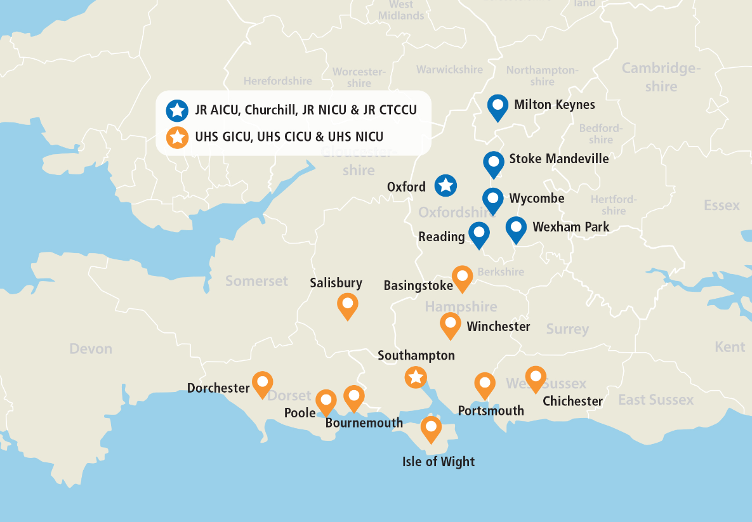

# **Appendix B Thames Valley & Wessex ACC ODN Transfer Form (v1.2 updated August 2019)**

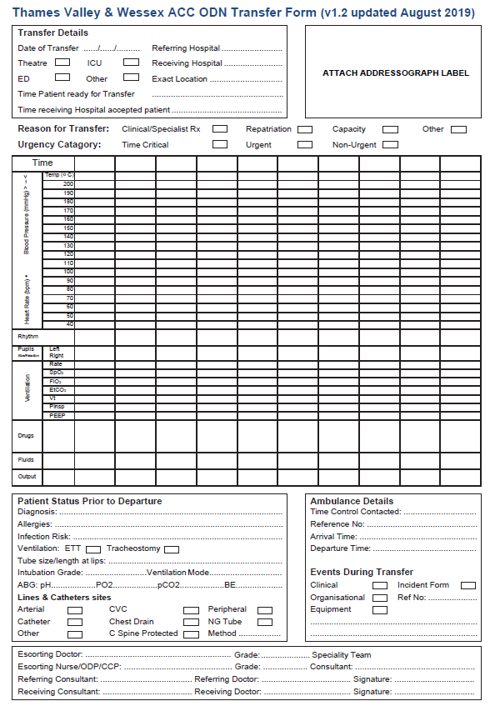

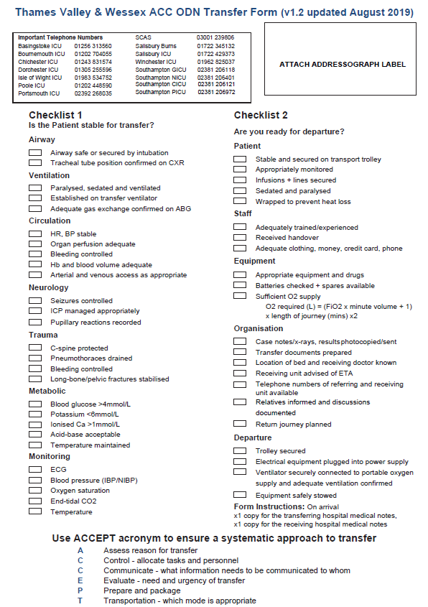

# **Appendix C** Transferring the patient with an intra-aortic balloon pump in situ

An Intra‐Aortic Balloon Pump (IABP) is a device which is used to assist the heart in time of crisis, for example unstable angina, mechanically complicated acute myocardial infarction, and/or cardiogenic shock. In these circumstances it can be used as a bridge to more definitive cardiac surgery.

The IABP works by increasing blood flow to the heart muscle and decreasing the heart’s workload through a process called counter pulsation. It inflates in diastole improving coronary perfusion and deflates before systole providing afterload reduction, reduced myocardial oxygen consumption, and improved cardiac output.

At times it will be necessary to transfer a patient with an IABP in place and as part of the communication ambulance control need to know that the transfer will include not only the patient but also the balloon pump, this helps them to prioritise care and crew accordingly.

It is imperative that the harness is secured to the pump according to the manufacturing instructions. The harness is compatible with all front-line ambulances and should always be secured to the ambulance floor in transit.

**The battery life of an IABP is between 2-4hrs and should NEVER be plugged into the ambulance electricity supply as they are not compatible with one another.**

When transferring a patient between hospitals it is paramount that you try and keep the patient as stable as you can throughout transit. It is advised that you do not wean the patient from the IABP in transit as doing so could have detrimental effects on the individual.

The patient, whether in transit or in a hospital setting, can only sit up between 30‐45 degrees so that the IABP catheter does not become occluded, and to ensure it remains in the optimal position.

If however the patient were to suffer a cardiac arrest during transfer it is advised you change the “trigger source” from “ECG” to “Pressure”. This is because the ECG trigger works on detecting the QRS complex and the “Pressure” trigger recognises systolic events like cardiac compression.

The IABP has a help menu and every time the alarm sounds a menu appears telling the user the problem and how to overcome it. The machine only has one alarm and is easily silenced if appropriate. The helium the machine uses lasts for up to three months with constant use and the IABP menu screen alerts the user two hours before the helium bottle is empty.

If the IABP is in standby for more than thirty minutes the machine will tell you this and it means it cannot be re‐started, this is because blood clots will have had the time to settle on the balloon and if it were to be restarted it could have detrimental effects on the patient. Therefore, the balloon needs to be removed and this is a medical responsibility only.

Regular observations should be carried out on the patient with an IABP at least every 60 minutes. Below are just a few examples of the observations needed

**Check left radial pulse** ‐ If the radial pulse changes/diminishes this may be an indication of the intra‐aortic balloon migrating and occluding the left subclavian artery 

**Observe insertion site** ‐ This is so the health care professional can observe for signs of bleeding

**Check pedal pulse** ‐ If the pedal pulse changes/diminishes this may be an indication that the limb is becoming ischemic

**Inspect tubing for signs of blood** ‐ If this occurs it means the balloon is damaged and treatment should be abandoned immediately

**Monitor for decreased urinary output** ‐ If this is the case it could be that the intra‐aortic balloon is occluding the renal arteries

# Appendix D Transferring the Neuro Patient

The main causes of secondary brain damage are raised intracranial pressure (ICP), hypotension, hypoxia, hypercarbia, cardiovascular instability, and hyperpyrexia. Most principles of safe transfer are common in all seriously ill patients but there are some specific features that apply to those with acute brain injury.

 CT Image of Extradural Bleed

These specific features have been identified by Association of Anaesthetics of Great Britain and Ireland and recommendations have been published (AAGBI 2019) these are summarised below.

**It is fundamental that these clinical parameters should be maintained throughout transfer:**

* mean Blood Pressure >80mmHg
* PaO2>13kPa
* PaCO2 between 4.5 – 5.0 k Pa.
* hyperventilation is justified if there is clinical or radiological evidence of raised ICP but not to reduce below 4.0 k Pa
* maintain normothermia.
* large bore orogastric tube on free drainage.
* 20 degree head up tilt – due regard to any possible spinal injury
* maintain head in neutral alignment

**Specific indications for Intubation & Ventilation for transfer after Brain Injury**

* GCS 8 or less
* significantly deteriorating conscious level (i.e. fall in motor score of two points or more)
* loss of protective laryngeal reflexes
* hypoxemia (PaO2 < 13KPa on oxygen)
* hypercarbia (PaCo2 > 6KPa)
* spontaneous hyperventilation causing PaCO2<4.0KPa
* bilateral fractured mandible
* copious bleeding into the mouth (e.g. from skull base fracture)
* seizures

**Additional continuous monitoring should include:**

* capnography (ETCo2)
* temperature (preferably core and peripheral)
* pupillary size & reaction

**Additional equipment may include:**

* warming/cooling blanket
* spinal board as it is rare that a head injury is an isolated incident
* ambulance trolley that allows 20-degree tilt while maintaining spinal immobilisation should be encouraged

Further Reading:

**National Institute for Health & Clinical Excellence (2007)** Head Injury – Triage, assessment, investigation & early management of head injury in infants, children & adults

**Fakhry SM, Trask AL, Waller MA, Watts DD (2006)** Management of brain injured patients by an evidence bases medicine protocol improves outcomes and decreases hospital charges.

The Journal of Trauma March vol.56 No.3 p492500

**Hughes R (2002)** Care of patients with brain injury in the critical care environment.

Professional Nurse 17 (10): p5937

**Farling P, Smith M (2006)** Transfer of brain injured patients –time for a change? Anaesthesia Vol 61 p 51920

**Brain Trauma Foundation (2000)** Management and prognosis of severe traumatic brain injury. [www.braintrauma.org](http://www.braintrauma.org)

**Safe transfer of the brain –injured patient: trauma and stroke** **(2019)** Association of Anaesthetists.<https://onlinelibrary.wiley.com/doi/full/10.1111/anae.14866>

# Appendix E Transferring the Spinal Patient

Currently most cases go to the nearest hospital rather than travelling directly to the tertiary centers. As a result, most district general hospitals receive patients with major injuries directly from the scene of the accident.

**All patients who have sustained blunt trauma should be suspected of having a spinal injury, so spinal precautions should be maintained from the outset**

The whole spine should be immobilised in the ‘neutral position’ – the cervical spine can be controlled manually or with a combination of hard collar, side head supports and tape, but bear in mind this may have to be removed for certain procedures e.g. intubation where manual inline immobilisation will be maintained. The use of a spinal board is invaluable but be aware of the time as pressure sores have been reported from only one hour of its usage.

Spinal injury should be suspected when

* mechanism of injury in a trauma patient
* there are reported symptoms of pain, swelling, sensory disturbance
* obvious signs of tenderness swelling, motor weakness
* cardiovascular instability because of neurogenic shock ‐ causing an interruption in the sympathetic nerve
* abnormal breathing pattern following trauma ‐ this could be a sign of paralysis of the diaphragm and intercostal muscles. Injuries to the cord above C3/C5 are incompatible with spontaneous breathing

Spinal injuries can be progressive, the patient’s level of weakness may increase as oedema develops ‐ **their airway can be at risk as the oedema progresses**

The patient must have all other injuries stabilised before transfer to another unit i.e. # pelvis as there is a risk of massive arterial and venous.

Patients with partial cord injury should receive high dose steroids as current evidence suggests this improves outcome. (Bracken M B 2008) **PLEASE SEEK ADVICE FROM SPECIALIST CENTRE BEFORE PRESCRIBING.**

Although you do not want to prolong your journey it should be a smooth trip at steady speed, avoiding road surfaces you know to be bumpy.

Ensure you have communicated to all who need to know and that both centers are aware of travel arrangements.

Further Reading

[www.SIA.co.uk](http://www.SIA.co.uk)

[www.spinalnet.co.uk](http://www.spinalnet.co.uk)

[www.bascis.co.uk](http://www.bascis.co.uk)

# Appendix F Transferring the patient for an MRI scan

MRI scanners use strong magnetic fields and radio waves to form images of the body. MRI has a wide range of applications in medical diagnosis and has an impact on diagnosis and treatment in many specialties. MRI is in general a safe technique but the number of incidents causing patient harm have risen. Contraindications to MRI include most [cochlear implants](http://en.wikipedia.org/wiki/Cochlear_implant) and [cardiac pacemakers](http://en.wikipedia.org/wiki/Artificial_cardiac_pacemaker), [shrapnel](http://en.wikipedia.org/wiki/Fragmentation_(weaponry)) and metallic [foreign bodies](http://en.wikipedia.org/wiki/Foreign_body) in the [orbits](http://en.wikipedia.org/wiki/Orbit_(anatomy)).

**Patient**

An MRI checklist should be completed for each patient each time they require an MRI scan. This checklist will identify any contraindications or risk factors to the use of MRI. If possible, the patient should complete this form however this is often not possible for critical care patients. If the patient cannot complete the form it should be completed on their behalf by the attendees, this may require looking through the notes. The patient’s notes may however not reflect their full history for example they may have received treatment previously in a different trust. For this reason, it is often beneficial to speak to the patient’s relatives and ask them to help complete the form. All metal objects must be removed from the patient prior to entering the scan room.

**Attendants**

Attendants should also look at the checklist as this will guide them as to whether they can go into the scan room or not. If they themselves have anything listed on the checklist, they should discuss their ability to enter the scan room with the MRI staff. Although the patient is usually transferred onto the scan trolley outside the scan room, it is important all attendants can go into the scan room to attend to the patient should an emergency arise. For this reason, if you are not MRI compatible you should not take patients to MRI scan and it may be necessary to find another attendant for the scan.

**Equipment**

As no metal objects can enter the scan room the equipment required to care for a critically ill patient requiring an MRI scan requires careful consideration. Discussion should occur between the attendants as to what equipment will be used during the scan prior to departure.

* **Ventilation**. An MRI compatible anaesthetic machine is usually used to ventilate the patient during the scan, this may also be used to sedate the patient during the scan in which case other sedatives may be discontinued while the patient is in the scan room.
* **Infusions**. Any infusions which are required to continue during the scan will need to have lines extended so the pump can remain outside the scan room. This should be done prior to leaving the Critical Care unit to ensure the pumps function properly as the extra length of lines can sometimes cause problems with pressure required to deliver the infusion and it is important to ensure the patient is stable on these infusions in a safe environment.
* **Monitoring.** It will be necessary to transfer the patient onto MRI compatible monitoring prior to them entering the scan room. This is usually provided by the MRI department. BP will usually only be available via NIBP. ECG dots are usually provided by the MRI department but remember to take spares for the return journey. Red cap bungs are also useful to have readily available to cap off arterial and central line monitoring. ICP bolts will need to be removed and reinserted if required post scan.

# Appendix G Aero medical considerations

The ICS guidelines (2019) recommend staff without appropriate training should not undertake aero-medical transfers. Minimum requirements include safety training, evacuation procedures for the aircraft and basic on-board communication skills. More advanced training in aero medical transfer is however desirable. Aero medical considerations are detailed below as a guide for those preparing a patient for air transfer and are not intended to prepare practitioners to undertake such transfers.

**Atmospheric pressure:** As altitude increases atmospheric pressure decreases. The extent to which reduced atmospheric pressure effects the patient depends on the type of aircraft being used, and more specifically if the aircraft is pressurised or not. Rotary-wing and small, fixed wing aircraft do not have pressurised cabins where larger commercial aircraft do. It is therefore cabin altitude which is relevant when considering the effects on the patient rather than flying altitude.

* **Partial pressure of oxygen.** As atmospheric pressure decreases the partial pressure of oxygen falls this leads to a corresponding fall in alveolar oxygen and may lead to hypoxaemia. It may therefore be necessary to increase FiO2 and it is essential that PaO2 and SPO2 are monitored.
* **Barometric pressure.** Boyle's law dictates that as barometric pressure falls the volume of gas will expand (pressure x volume=constant). This is an important consideration as it will affect any gas filled cavities in the patient. This includes endotracheal cuffs, the pressure of which should be monitored pre, during and post flight. NG tubes should be inserted and placed on free drainage to compensate for distension of the gastrointestinal tract due to the expansion of gas. Similarly, pneumothoraces will enlarge and must therefore be drained pre-flight. Pneumo-peritoneum and intercranial air are relative contra indications to air transport (ICS 2019). Tissues may also swell, and plaster casts should be split if they have been applied within the last 14 days.

**Environment.** The following environmental effects should be considered as they are likely to cause the patient nausea and pain and prove a difficult working environment for the attendants. Additional pain relief, an anti-emetic, additional insulation, and ear protection may all be required.

* **noise**
* **vibration**
* **temperature**
* **cramped conditions**

# Appendix H Ambulance Escalation

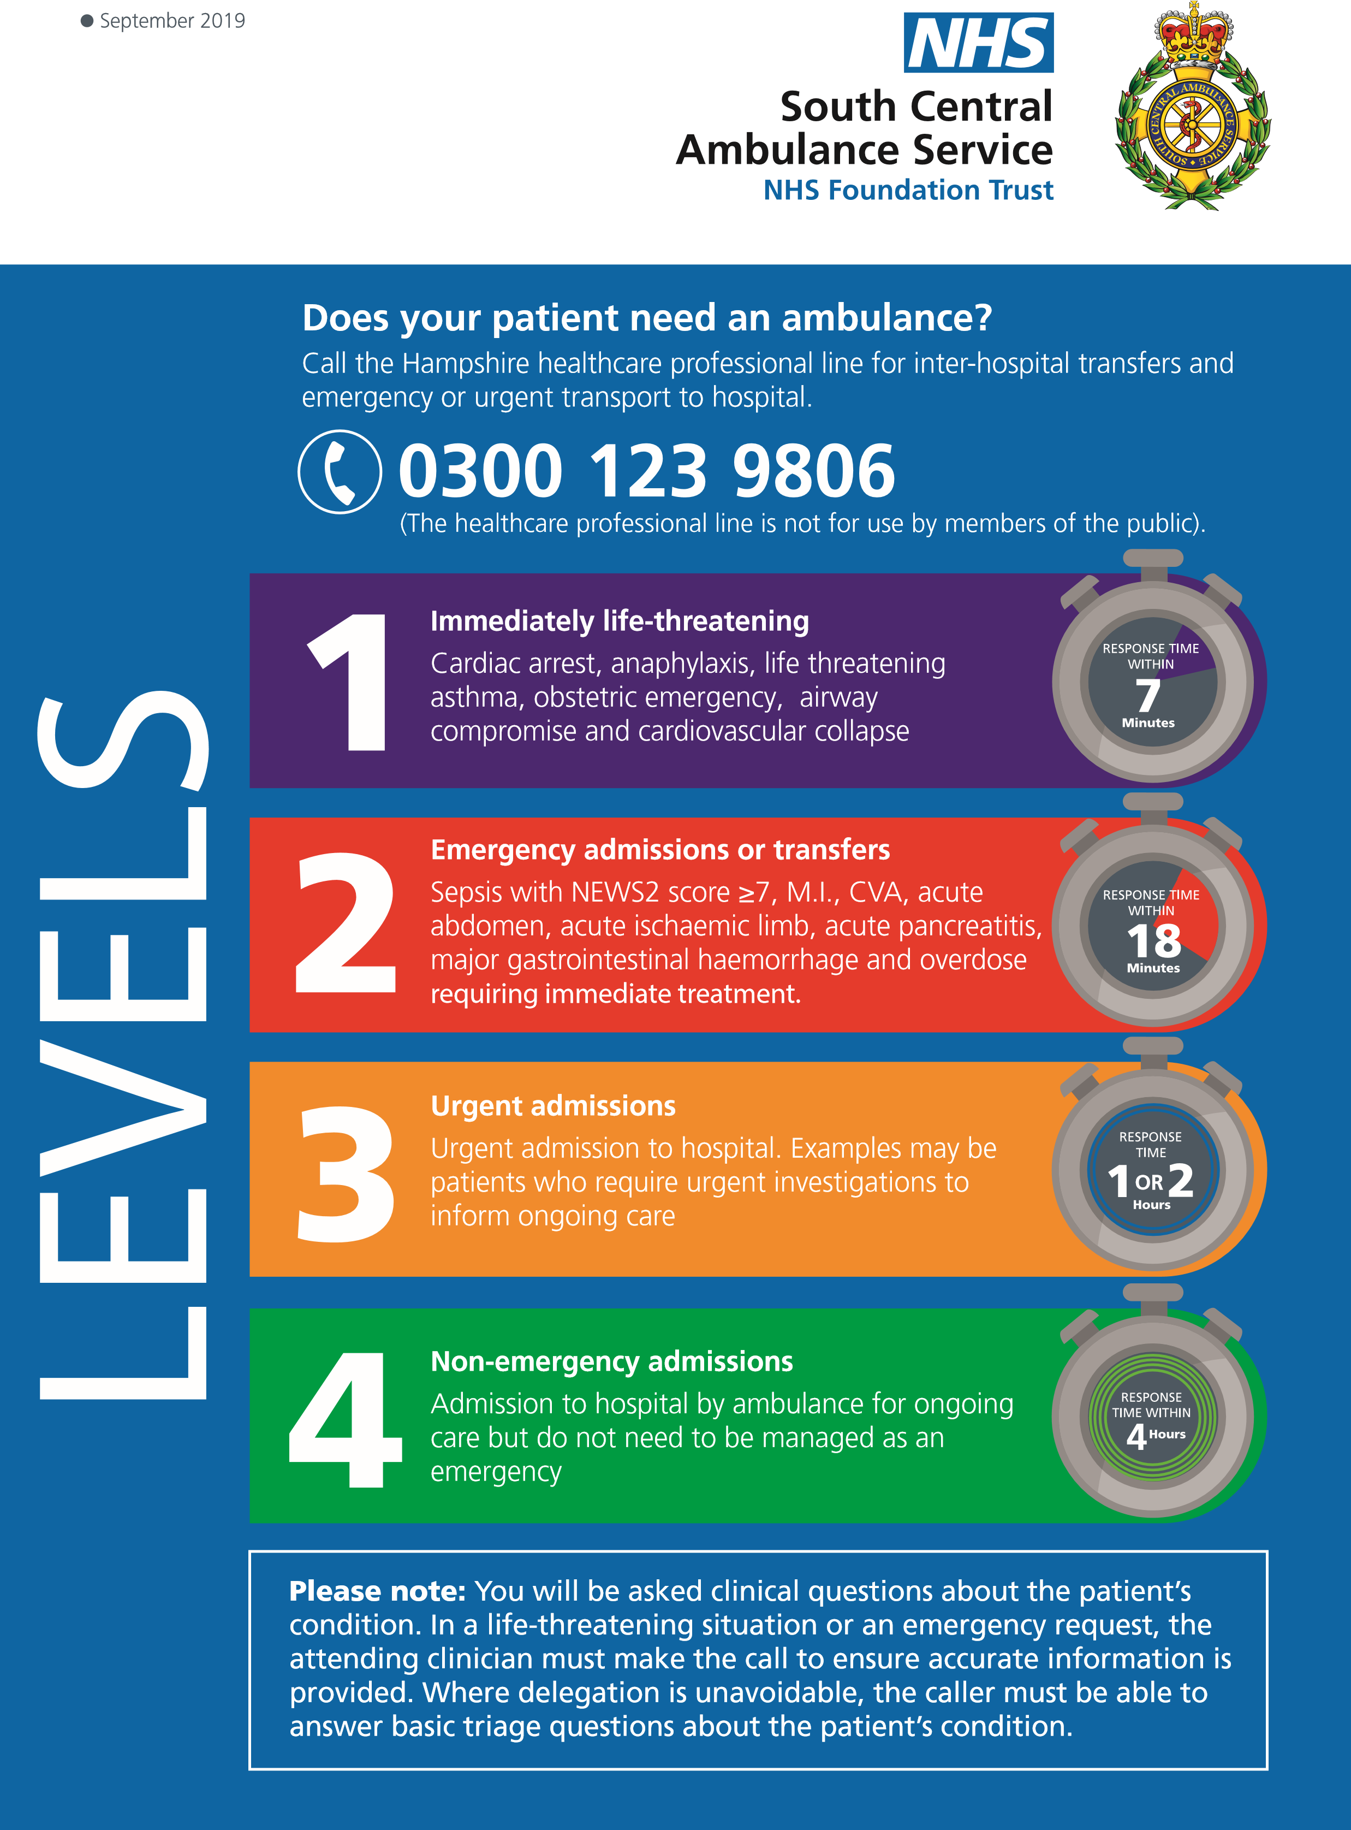

# Appendix I Hyperlinks

**https://southodns.nhs.uk/our-networks/adult-critical-care/?sub=thames-valley-wessex**<https://www.cc3n.org.uk/uploads/9/8/4/2/98425184/01_new_step_1_final__1_.pdf>

<https://www.cc3n.org.uk/uploads/9/8/4/2/98425184/02_new_step_2_final.pdf>

**Hyperlinks for relevant sections of the FICM training syllabus and core competencies for transfer of the critical care patient.**

**Syllabus**

[**https://www.ficm.ac.uk/sites/default/files/cct_in_icm_part_iii_-_syllabus_2019_v2.4.pdf**](https://www.ficm.ac.uk/sites/default/files/cct_in_icm_part_iii_-_syllabus_2019_v2.4.pdf)

**Core competencies**

[**https://www.ficm.ac.uk/sites/default/files/cct_in_icm_part_iv_-_core_and_common_competencies_2019_v2.4_final.pdf**](https://www.ficm.ac.uk/sites/default/files/cct_in_icm_part_iv_-_core_and_common_competencies_2019_v2.4_final.pdf)

**Assessment stages**

[**https://www.ficm.ac.uk/sites/default/files/cct_in_icm_part_ii_-_assessment_system_2019_v2.4_final_0.pdf**](https://www.ficm.ac.uk/sites/default/files/cct_in_icm_part_ii_-_assessment_system_2019_v2.4_final_0.pdf)

# Appendix J Logbook

|  |  |  |  |  |
| --- | --- | --- | --- | --- |
| Date of Transfer | Destination | Team Feedback | Personal Reflection | Signature |
|  |  |  |  |  |
|  |  |  |  |  |
|  |  |  |  |  |
|  |  |  |  |  |
|  |  |  |  |  |

# Version Control:

|  |  |  |  |  |
| --- | --- | --- | --- | --- |
| **Version** | **Date** | **Details** | **Author(s)** | **Comments** |
| 1 | 08.07.20120 | Draft | GL | Update and grammar checks |
| 2 | 10.07.2020 | Draft | GL, CB, NM | Agree changes |
| 3 |  | Draft |  |  |
| Final | 30.09.2020 | Final |  |  |
| **Review Date:** | **Oct 2022** |  |  |  |