Simulation Training for ICU at the Bristol Royal Infirmary

Since May 2025, General Intensive Care (GICU) has provided reliable point-of-care simulation training every Friday for the multidisciplinary team, including medics, medical students, nurses, nursing associates, ECMO nurses, students, and ACCPs. Delivering scenario-based training directly within the clinical environment allowing Simulation based education to become embedded in staff’s normal working routines. Our ongoing aim is to foster a culture of point-of-care education and simulation across the unit, Divisions and Trusts.
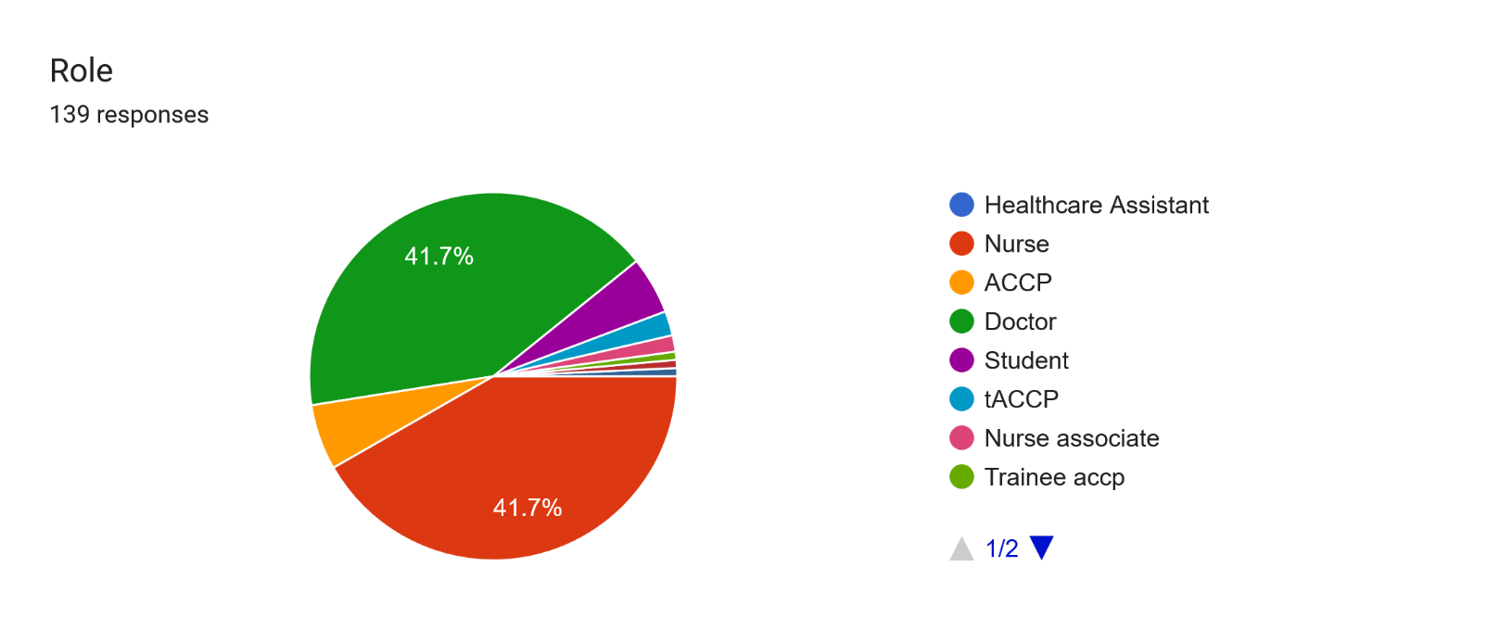
Over the past six months we have delivered reliable, high quality multidisciplinary simulation training on the General Intensive Care Unit (GICU) every Friday. This programme has played a significant role in improving clinical skills, decision-making, and interprofessional communication. We have covered a wide range of topics, including the Trust-wide Civility Saves Lives campaign and acute clinical scenarios such as major haemorrhage and sepsis. Delivering this training at the point of care within staff’s normal clinical environment, has received strong engagement and helped embed simulation into the unit’s weekly routine. Each scenario is reviewed by our multidisciplinary faculty to ensure all professional groups have appropriate learning outcomes. Scenario writing responsibilities rotate among faculty members, and regular meetings ensure we remain well-prepared for each simulation. The faculty consists of 1 overseeing consultant, 2 advanced trainees, 4 Practice education facilitators, and 2 technicians. Alongside rotating medics. A key strength of our programme is its multidisciplinary design. Learning objectives and scenarios are developed collaboratively by the entire faculty.

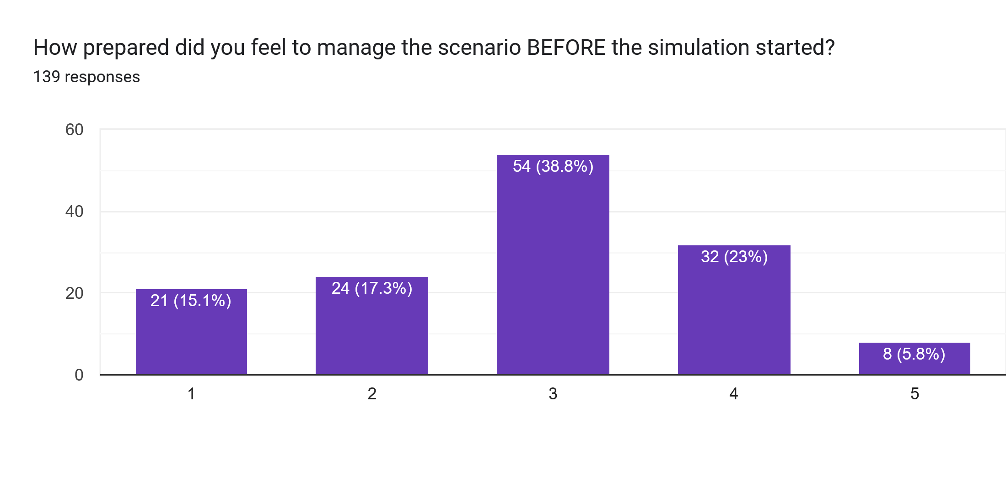
Faculty and simulation development is designed to support improved patient care, staff retention and progression across the full MDT. We have received majority positive feedback towards this method of training. Over 92% of participants felt that our MDT simulation had a positive impact on their confidence in managing the scenarios covered, and 97% of participants felt the scenarios were relevant to their practice. We have also received direct feedback from colleagues. One member of the medical team shared that, after participating in our simulation on decision-making in cardiac arrest, where no reversible causes were identified and CPR was discontinued, he later faced an almost identical real-life scenario. He explained that the simulation had empowered him and enabled him to manage the situation with confidence and compassion.
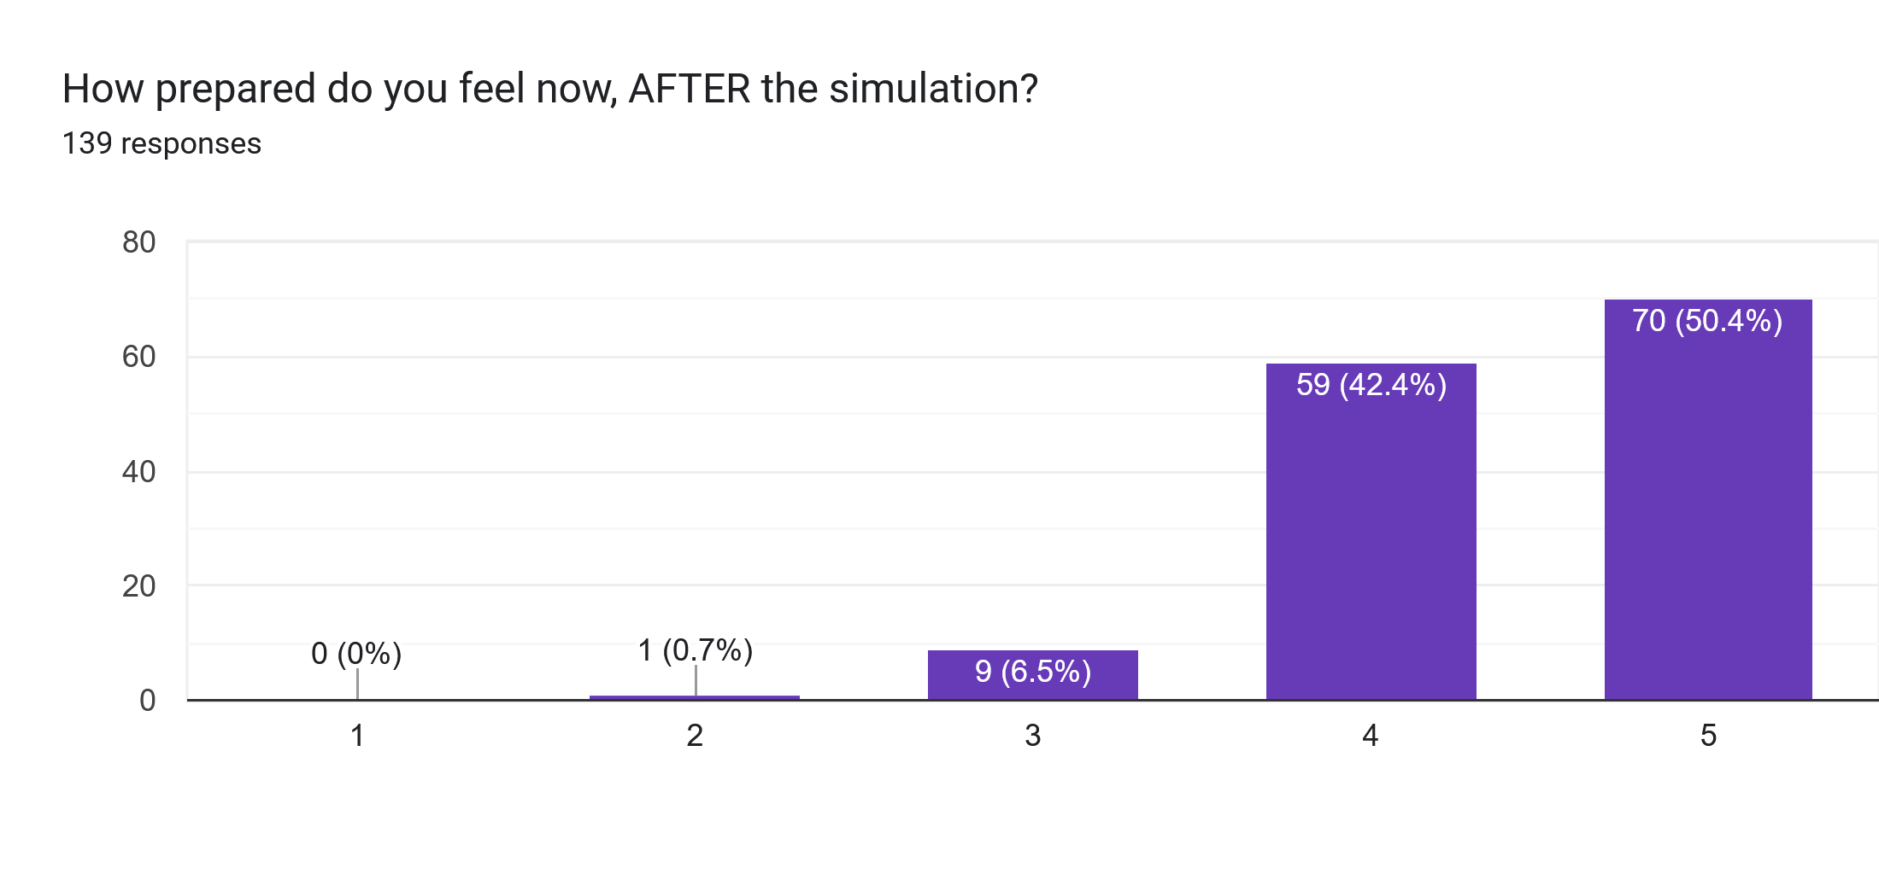
Over the past six months, we have continually enhanced the realism and complexity of both scenarios and the training environment. In response to participant feedback and our own reflections, we have introduced several innovations to strengthen the programme. The most beneficial have been:

Securing an education bedspace:
Although the unit is funded for 28 beds, we operate with 32. We now have a flexible bedspace where simulation equipment can be moved depending on patient acuity. When the unit is full, we make use of the GICU equipment room, though this has only been required twice. We also created a booking system that allows teams across GICU and CICU to reserve the space for teaching.
Introducing a mobile simulation equipment trolley:
This allows us to move equipment efficiently and makes it easy for senior nurses to pack away and relocate the trolley out of hours if the bed is needed for a patient.
Establishing a simulation attendance register and feedback system:
We maintain a register of participants to ensure equitable access to training and use QR-code feedback forms to support continuous improvement. The faculty also completes a debrief after each session to capture learning and identify improvements.
Creating a simulation profile within the Philips system:
This enables participants to access electronic notes for the simulated ‘patient,’ improving realism and familiarisation with clinical documentation.
Embedding MDT simulation into GICU nursing essential training:
This ensures nurses are pre-allocated and given protected study time to attend simulation sessions.

When discussed at regional level, it became clear that no other ICU in the Southwest currently delivers MDT simulation in this frequency and quality at point of care. This has been confirmed through a recent questionnaire completed by 13 ICUs across the region. Only Retrieve are able support weekly MDT simulation. The majority of units (54%) offer simulation training no more than once per month, however 85% of units support it as a training tool.
Like other units in the Southwest, we are experiencing additional pressures over the winter months, made more challenging by the ongoing building work on CICU, which has reduced our overall capacity. As a result we will have limited bed availability and staffing difficulties.
To minimise disruption to our simulation programme, we have put several important measures in place. We will continue to use the education bed space whenever it is available and have agreed that it does not need to be a side room, provided neighbouring patients are informed that training is taking place. We have also successfully run simulations in the equipment room; feedback indicated that staff did not feel significantly distracted during these sessions.
The matrons have agreed to support nursing staff by allocating study time specifically for simulation. This will allow staff to fully engage in the scenarios without concern about patient cover. Staff will be allocated 1–2 hours of study time either before or after a late shift, enabling us to run two simulation sessions every Friday. This goes some way to bridge the gap in protected education between medics and nursing staff.
We aim to deliver shorter 30-minute simulations over the winter months to reduce the impact on the unit in regards unit acuity.

Our aim going forward is to produce a simulation study day where we can engage staff that have flexible working and cannot attend on Fridays, as well as develop linked simulation sessions over the next 6-12 months with NBT and WGH, increasing educational collaboration across the trusts. These opportunities will significantly broaden the reach and impact of the programme, as well as further cementing University Hospitals Bristol and Weston’s position as a leading trust in the field of point-of-care simulation training.

